**Trouble For Sammy**

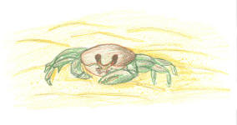Sammy was so tired. It had been a long night already. First, he had been confused. Then he had gotten lost. Sammy was trying to find the beautiful moonlight reflecting off the water.

It was supposed to be like a guiding light. Somehow, he’d missed it. If it hadn’t been for that nice man, Sammy would still be lost and in trouble. With a kind and gentle voice, the older man had said, “Little fella, you seem to be going in the wrong direction. Let me give you a hand.”

Oh, there was the water. He could see the moonlight shining brightly on its surface. Without looking back, Sammy made his way to the ocean. It would be the last time Sammy ever came onto land again. All he had to do was get into the water and swim.

Suddenly, as Sammy was almost into the ocean, a ghost crab came scooting across the sand. Crabs ate sea turtles like Sammy. Sammy’s short life was in danger. He tried to move quicker. The ghost crab moved directly toward Sammy and …